Accession No. : N/A
Designer: Harry Bertoia
Title (Date): Ottoman Bird Stool from the Barbara Hepworth Museum, c. 1950
Overall dimensions as displayed: 380 x 615 x 440mm
Overall weight: 4 kg.
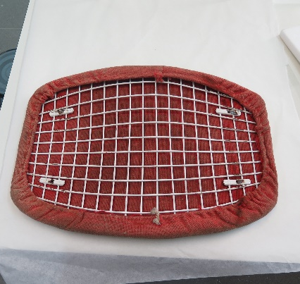
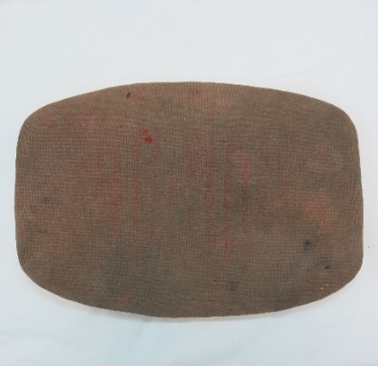
Fig. 1-3. Before treatment footstool, top cover, underside of cover.

DESCRIPTION
Summary description
An Ottoman Bird stool designed by Harry Bertoia in 1952, bought by Barbara Hepworth in the 1960s to be used in her greenhouse in St. Ives. The stool is displayed in the greenhouse of Hepworth’s house and is intended to be used by the public.
Fabrication and assembling
The footstool is covered with red, plain weave wool or wool blend fabric, and is padded with an underlying layer of foam, polyester with kaolin (identified with FTIR), used in upholstery since the late 1950s. The use of kaolin suggests that a dense foam was required, one that would retain a moulded shape. The foam was produced in a mould, and the fabric applied to it with an adhesive. The cover is applied onto a welded steel frame coated in polyamide (identified with FTIR). The steel seat attaches to the steel base by four screws and nuts.
Surface finish
Used.

TREATMENT AIMS
- To restore the footstool so that it is usable by the public and aesthetically as Hepworth intended.
- To estimate the longevity of the treatment choices.
- To incorporate maintenance of the footstool into the treatment plan.

CONDITION BEFORE TREATMENT
Structural condition
Structurally the welded steel bases are sound. The screws connecting the steel base and seat have been sheered so these elements are loose (fig. 4). There are four screws and bolts missing from the footstool. The polyamide coating on the base is delaminating from the metal, resulting in losses which are mainly concentrated at bolt to bracket joints and on the metal rods that have contact with the floor (fig. 4). The foam within the seat pads has severely deteriorated, loosing flexibility and becoming dense and granular (fig. 5).
Surface Condition
The surface condition is poor. The footstool is covered in surface dirt. The top cover is extremely faded and worn with staining (fig. 6). It has a stiff feel, which could be the result of the deteriorating foam or the adhesive applied to adhere it to the foam. The steel base is exhibiting orange corrosion, with local corrosion staining on top of the polyamide coating (fig. 7).

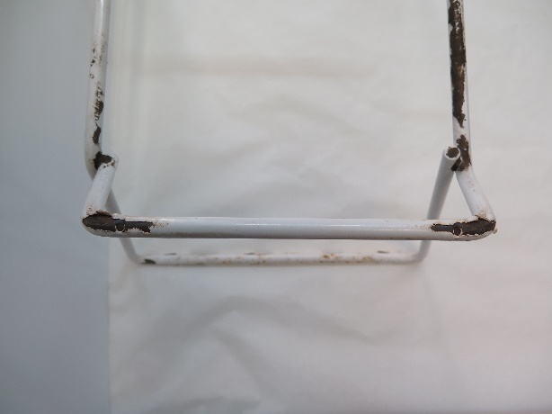  Fig 4. Sheered screws and polyamide coating delaminating | 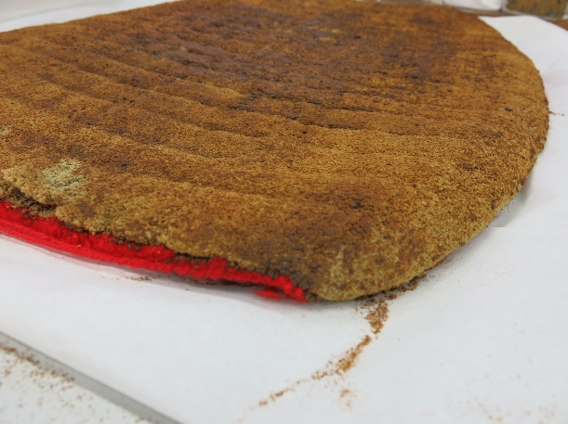  Fig. 5. Degraded foam within the cover.
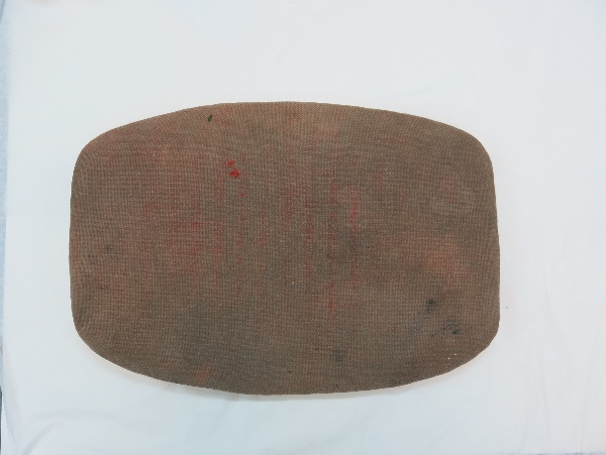  Fig. 6. Stained and faded cover. | 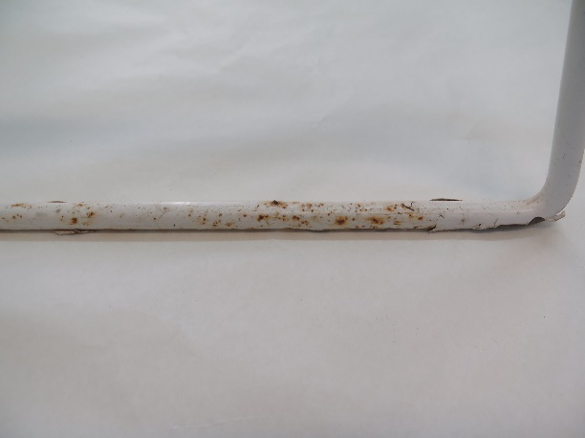  Fig. 7. Corrosion on the steel frame and staining on the polyamide coating.

TREATMENT METHOD

- Cleaning of original seat cover
  - The seat cover was removed from the welded steel frame by undoing the drawstring mechanism. Pieces of longer string were attached to the drawstring so that it would not become lost in the cover.
  - The degraded foam was removed manually using spatulas to lift it away from the fabric. A stiff brush and vacuum were used to remove as much foam as possible from within the seat cover.
  - The seat cover was washed in a shallow tray with deionised water and a drop of Dehypon LS 45, rinsing with deionised water three times. A medium density brush was used to agitate the dirt from the fabric.
  - The original seat cover was packed in a Foam Core box (acid free board with polyurethane foam core). An interior support for the cover was made from polyethylene foam, to prevent the fabric from losing its shape.

- Upholstering a new seat cover
  - A wool/viscose blend fabric (Hallingdal 65, colour #0674 by Kvadrat) was used for upholstering.
  - Running stitch was used for the drawstring section using Gütermann Extra Strong thread, in a colour similar to the fabric. A polyester drawstring was inserted through the cover.
  - Underside of seat pad was cut to size and hemmed.
  - Polyethylene foam was used for padding, cut to size with a chamfer edge to cover the edge of the metal seat.
  - The fabric was adhered to the polyurethane foam with a water-based contact adhesive based on polychloroprene (Evostic solvent free contact).

- Stabilising the metal base
  - The polyamide coated base was cleaned with deionised water.
  - Corrosion was removed from the steel frame by swelling with white spirits, before using 0000 grade steel wool to remove mechanically.
  - Delaminating polyamide was consolidated with Paraloid B-48N, 30% methyl proxitol.
  - The exposed metal was sealed with Renaissance Microcrystalline wax.
  - The metal seat was attached back to the base with four screws and nuts. The base had warped and so it was necessary to apply tension with a clamp to insert the screws.

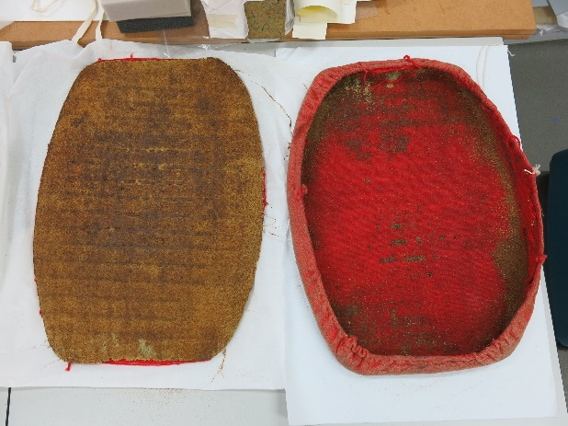  Fig. 8. Removal of degraded foam. | 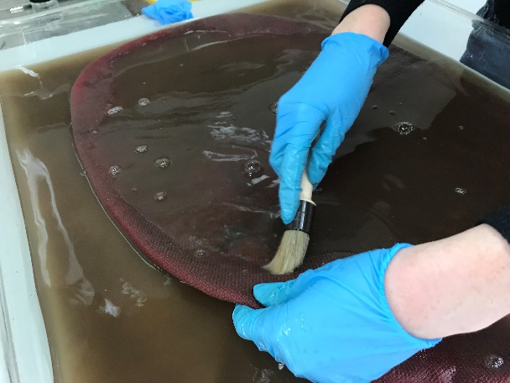  Fig. 9. Washing the footstool cover.
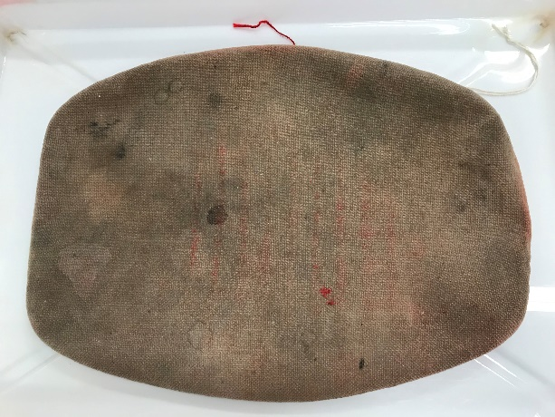  Fig. 10. Before washing. | 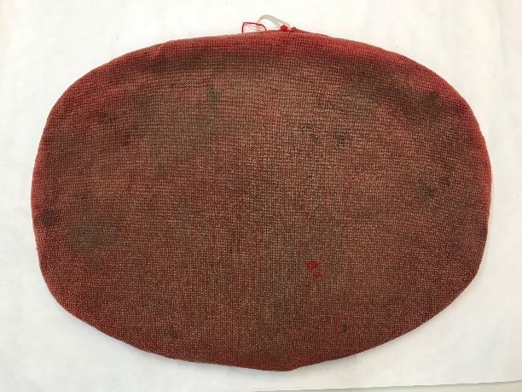  Fig. 11. After washing.
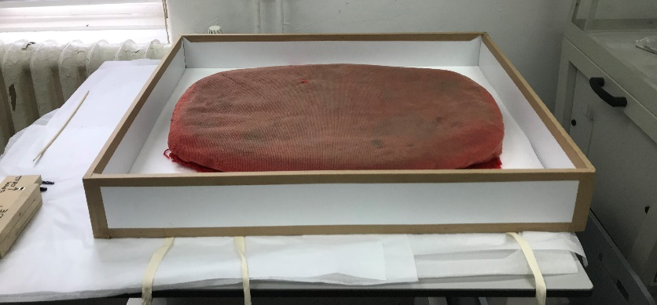
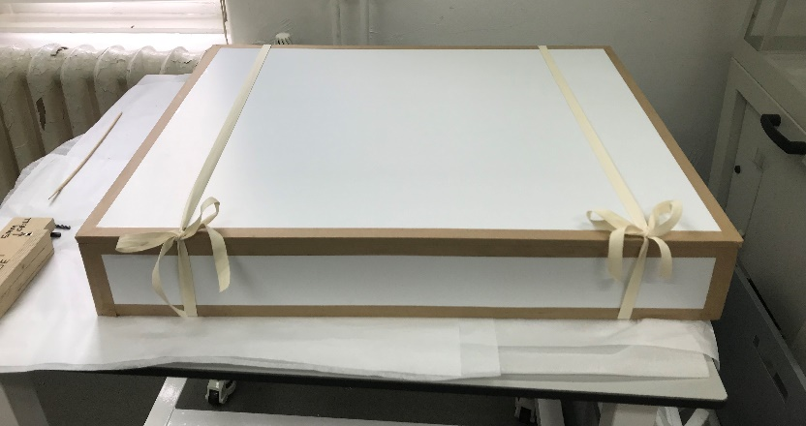
Fig. 13 and 14. Packing.

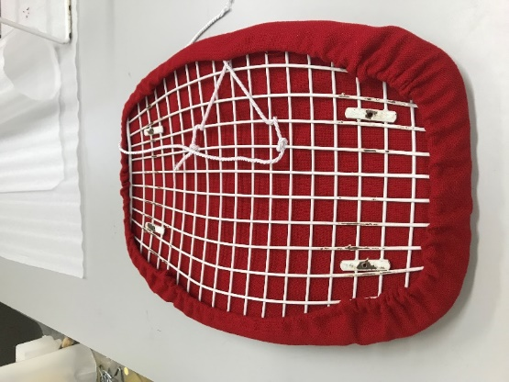  Fig. 15. Upholstered replacement cushion. | 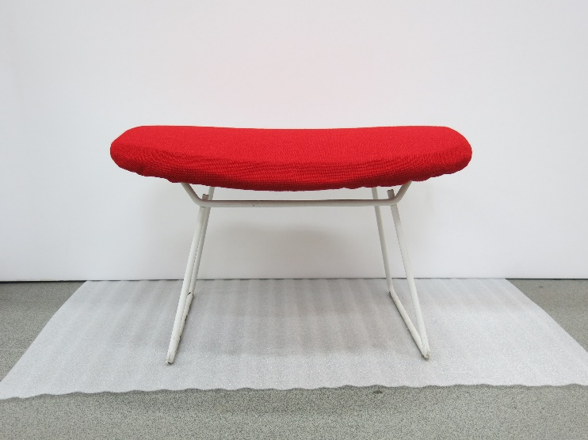  Fig. 16. After treatment

AFTER TREATMENT
This treatment has stabilised the footstool, reducing the risk of further damage or visual change to the original seat cover through display and use. The materials chosen for the treatment had to strike a balance between looking aesthetically like the original seat cover, whilst being durable enough for the public to use. Hallingdal 65 was used to produce Bertoia footstools in the 1960s, whilst the adhesive chosen has a high enough tensile strength to withstand public use.
The fluctuating environmental conditions, UV exposure and public use mean that this treatment will have to be monitored for visual and structural changes. Maintenance should be incorporated into the treatment plan to monitor rate of change.
Short term maintenance:
- Hoover under cushion to remove any potential pests.
- Apply constrain to fabric monthly.

Yearly maintenance:
- Assess rate of fade, monitoring for pests and wear and tear from use.

Long term maintenance:
- Replace covers every 7-10 years depending on level of fade, wear and damage.
- There is enough spare fabric in the Sculpture Conservation Studio at Tate Britain for another seat cover.

Location of examination: Sculpture Conservation Studio Tate Britain
Examiner: Alice Watkins
Date: 31.05.2019

