Accession No. : N/A
Designer: Harry Bertoia
Title (Date): Ottoman Bird Stool from the Barbara Hepworth Museum, c. 1950
Overall dimensions as displayed: 380 x 615 x 440 mm (h, w, d).
Overall weight: 4 kg

DESCRIPTION
Summary description
An Ottoman Bird stool designed by Harry Bertoia in 1952, bought by Barbara Hepworth in the 1960s to be used in her greenhouse in St. Ives. The stool is displayed in the greenhouse of Hepworth’s house and is intended to be used by the public.
Number of parts with dimensions and weight
1 part. Dimensions: 380 x 615 x 440mm, weight: 4 kg.
Fabrication and assembling
The footstool is covered with red, plain weave wool or wool blend fabric, and is padded with an underlying layer of foam, polyester with kaolin, used in upholstery since the late 1950s. The use of kaolin suggests that a dense foam was required, one that would retain a moulded shape. The foam was produced in a mould, and the fabric applied to it with an adhesive. The cover is applied onto a welded steel frame coated in polyamide. The steel seat attaches to the steel base by four screws and bolts.
Surface finish
Used
Inscriptions
None visible

CONDITION
Structural condition
Structurally the welded steel bases are sound. The screws connecting the steel base and seat have been sheered so these elements are loose. There are four screws and bolts missing from the footstool. The polyamide coating on the base is delaminating from the metal, resulting in losses which are mainly concentrated at bolt to bracket joints and on the metal rods that have contact with the floor. The foam within the seat pads has severely deteriorated, loosing flexibility and becoming dense and granular.
Surface Condition
The surface condition is poor. The footstool is covered in surface dirt. The top cover is extremely faded and worn with staining. It has a stiff feel, which could be the result of the deteriorating foam or the adhesive applied to adhere it to the foam. The steel base is exhibiting orange corrosion, with local corrosion staining on top of the polyamide coating.

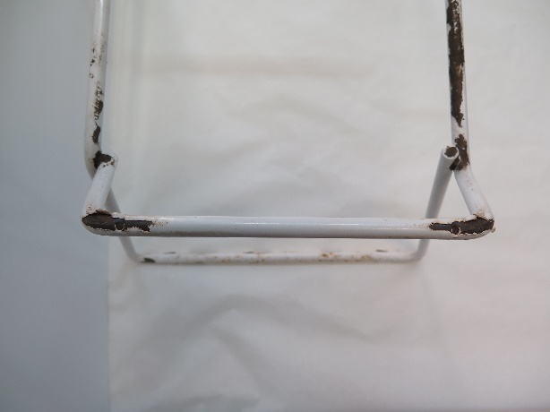  Fig 1. Sheered screws and polyamide coating delaminating | 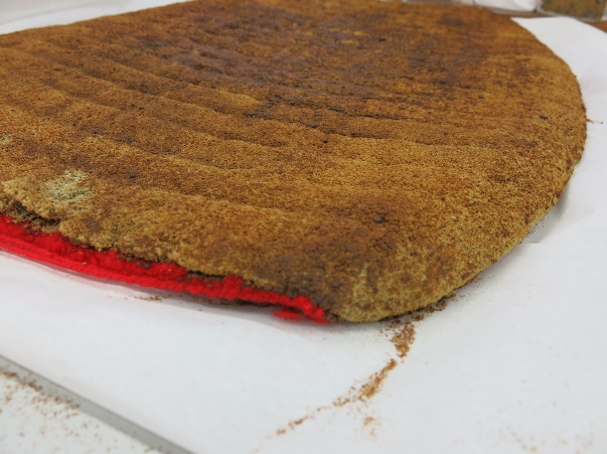  Fig. 2. Degraded foam within the cover.
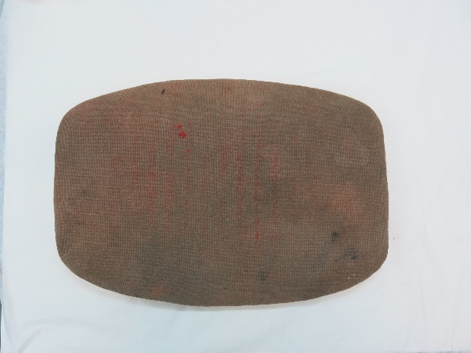  Fig. 3. Stained and faded cover. | 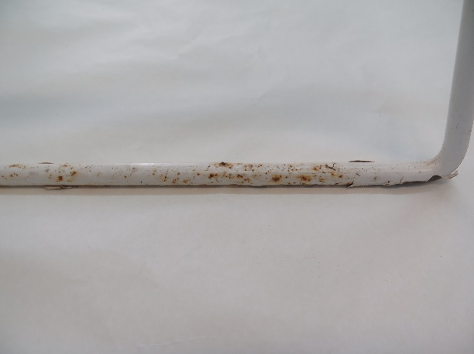  Fig. 4. Corrosion on the steel frame and staining on the polyamide coating.

TREATMENT AIMs

- To restore the footstool so that it is usable by the public and aesthetically as Hepworth intended.
- To estimate the longevity of the treatment choices.
- To incorporate maintenance of the footstool into the treatment plan.

DECISION-MAKING: TREATMENT OPTIONS
- Wash and use original seat cover: Washing may bring back flexibility to the textile and the footstools historical authenticity will be upheld. However, the greenhouse environment will continue to deteriorate the fabric, which has been analysed to be as light-sensitive as a work on paper. Risks: colour fading more, structural damage from use.
- Upholster new seat cover: Upholstering with new fabric will allow the footstool to look as it did when Hepworth was alive and can be used by the public without risk of further damage to the original fabric, which can be placed into archival storage. Risks: fabric will fade over time and may have to be replaced every 7-10 years.

Given the fragility of the original fabric, it is decided to undertake option B.

TREATMENT PROPOSAL
- Remove original seat cover, remove degraded foam and aqueous clean in a shallow tray with demineralised water and a drop of Dehypon LS 45, rinsing with demineralised water. The original seat cover is then archived.
- Make a pattern of the original seat pad and reupholster with Hallingdal 65 #0674, an archival fabric of wool/viscous blend that matches the warp/weft and colours of original fabrics.
- Replace the foam with high density polyethylene foam. Adhere the foam to the fabric cover with contact adhesive.
- Spot treat corrosion on metal locally by swelling the corrosion initially with white spirits on a cotton swab. If necessary, use fine (0000 grade) steel wool for the rest of the corrosion.
- Seal exposed metal with microcrystalline wax.
- Remove surface dirt from the polyamine coating with demineralised water and cotton swabs.
- Consolidate the delaminating polyamine coating with Paraloid B44N 30% methyl proxitol.
- Remove failed bolts from stool seat and reattach wire seat to base with replacement screws and nuts.
- Attach new seat cover to wire seat with drawstring mechanism.

TREATMENT OUTCOMES
After treatment the original fabric will no longer be at risk of further damage and will act as a reference for future treatments. Cleaning will remove visually disturbing stains and bring more flexibility into the material. The footstool seat will be able to be used safely by the public and will be aesthetically in line with how it was when Hepworth was alive.
However, as the footstool is being placed back into the uncontrolled environment of the greenhouse at the Barbara Hepworth Museum, the new textile will be expected to fade over time and become stained and worn from use. It’s recommended that the rate of fade be monitored each year and replacing the seat-pad be incorporated into the maintenance plan.

EXPECTED TREATMENT TIMELINE
Documentation: 1 day
Testing and research: 2 days
Treatment: 10 days.

Location of examination: Sculpture Studio Tate Britain
Examiner: Alice Watkins
Date: 09.05.2019

